RICE
Takeaway Menu

Boiled Rice £2.80
Pilau Rice £3.50
Keema Rice £3.95
Special Fried Rice £3.95
Khuska Rice £3.95
Nuts and sultana
Mushroom Rice £3.95
Egg Rice £3.95
Vegetable Rice £3.95
Peas Rice £3.95
BANQUET SET MEAL FOR 1
Choose your own:
1 x Papadom, 1 x Starter 1 x Main Dish, 1 x Side Dish
1 x Rice (boiled/pilau), 1 x Nan
FOR ONLY £19.95
- Excluding: King Prawns, Tandoori Mix Grill, Bandari Platter, Any Biryani, Chatpoti Chicken & Fish Grill
Any Special Rice £1.00 Extra

BANQUET SET MEAL FOR 2
Choose your own:
2 x Papadoms, 2 x Starters 2 x Main Dishes, 1 x Side Dish 2 xRice (boiled/pilau), 1 x Nan
FOR ONLY £34.95
- Excluding: King Prawns, Tandoori Mix Grill, Bandari Platter, Any Biryani, Chatpoti Chicken & Fish Grill
* Any Special Rice £1.00 Extra
Onion Rice £3.95
Garlic Rice £3.95
Lemon Rice £3.95
Cheese Rice £3.95
Coconut Rice £3.95

BREAD
INDIAN RESTAURANT

Naan £3.25
Keema Naan £3.95
Peshwari Naan £3.95
Stuffed Vegetable
Naan £3.95
Garlic Naan £3.95
Cheese Naan £3.95
Chicken Tikka Naan £3.95
Chilli Chicken Tikka Naan £3.95 Garlic & Coriander
Naan £3.95
Onion and Garlic
Naan £3.95
Chilli Nan £3.95
Chilli & coriander
Naan £3.95
Balti Naan £3.95
Paratha £3.95
Stuffed Paratha £3.95
(vegetables)
Chapatti £1.95
Puri £1.95

DELIVERY AVAILABLE
on orders over £15.00
ORDERS UNDER £20.00 CASH ONLY
Open 6 days a week.
Tuesday - Sunday: 5pm - 11pm Closed on Mondays
Except bank holidays

SIDE DISHES
Can be served as a main dish

01507 600 336 / 01507 604 211

Bombay Potato £4.95
Chana Bhaji (Chickpeas) .£4.95 Bhindi Bhaji (Okra) £4.95
Cauliflower Bhaji £4.95
Mushroom Bhaji £4.95
Vegetable Bhaji £4.95
Vegetable curry £4.95
Aloo Gobi £4.95
Cauliflower & Potato
Aloo Chana £4.95
Potato & Chickpeas
Aloo Methi £4.95
Potato & Fenugreek
Saag Aloo £4.95
Spinach & Potato
Saag Panir £4.95
Spinach & cheese
Saag Bhaji (Spinach) £4.95
Chana Panir £4.95
Chickpeas & Cheese
Tarka Dall £4.95
Raitha £1.95
(Cucumber or Onion)
Chips £4.95
Curry Sauce £4.95
.C.hicken Noodles £4.95
Egg Noodles £4.95
Special Noodles £4.95
Fried Noodles £4.95

www.asha-indian.co.uk
136 Eastgate, Louth, LN11 9AA
For latest reviews visit

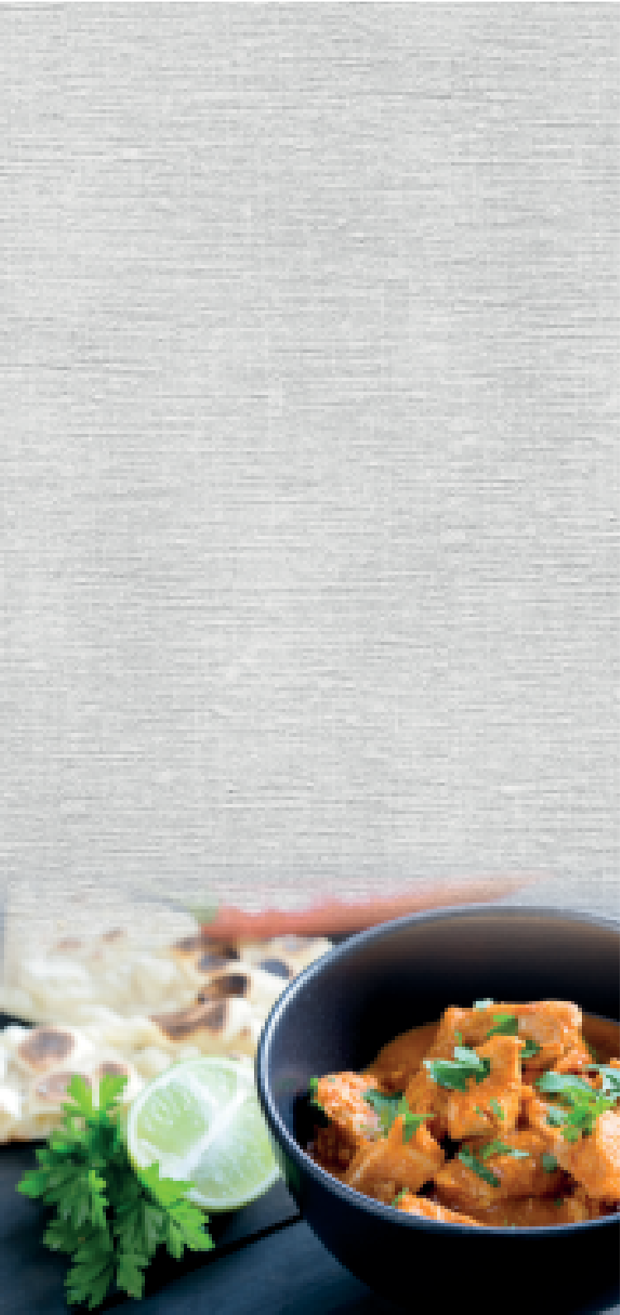
PAPADOM AND PICKLES
WE ALSO PROVIDE OUTSIDE CATERING SERVICE FOR BIRTHDAYS, ANNIVERSARIES AND ALL OTHER FUNCTIONS
Papadom £1.25
Spicy Papadom £1.25
Mint Sauce £1.25
Mango Chutney £1.25
Lime Pickle £1.25
Coconut Chutney £1.25
Onion Salad £1.25
Pickle Tray £4.50

Terms & condition of service :
When you spend £40 or more can request a
FREE PICKLE TRAY
(Offer not available with banquet set meals)
- All major credit and debit cards accepted - orders over £20
DESIGN & PRINT: IMPRESS MEDIA UK 020 7168 1224
- All offers can be withdrawn at any time without notice
- If a specific dish you want does not appear on our menu please ask a member of staff and we will try our best to accommodate your request. (Price may vary)
- Management reserves the right to refuse service
- All prices include V.A.T and are subject to change
- All information is correct at the time of going to print
(January 2024)

ALL INDIVIDUAL ITEMS ARE SOLD SEPARATELY
ASHA’S SIGNATURE DISHES
TRADITIONALS

STARTERS
Chicken Tikka or Lamb Tikka £4.25
Sheek Kebab £4.25
Shami Kebab £4.25
Mini Mix Starter (Sheek kebab, chicken tikka, lamb tikka) £4.25
Spicy Fried Chicken Wings £4.25
Chicken Pakora £4.25
Chicken Satay £4.25
Chicken Tikka Wrap £4.25
Mushroom Pot (Contains chicken) £4.25
Chicken Chat Puri £4.25
Cheesy Chicken £4.25
Chicken Tikka cooked with Naga and covered in melted cheese
Ali Baba Pot £4.25
Small cubes of chicken tikka blended with potato, green pepper, carrot, onion cooked to a mild creamy taste and topped with cheddar cheese.
Asha Chicken £11.95
Chicken fillet marinated in herbs and spices and cooked in a mild sauce with a touch of single cream, topped with fresh tomatoes and fried garlic.
Chicken or
Lamb Tikka Masala £11.95
This dish is prepared with a specially made Masala sauce, cooked
with fresh cream and almonds.
King Prawn Tikka Masala £15.95
This dish is prepared with a specially made Masala sauce, cooked
with fresh cream and almonds.
Cocktail Masala - Chicken, Lamb, Kofta Kebab £11.95
This dish is prepared with a specially
made Masala sauce, cooked with fresh cream and almonds.
Chilli Garlic –
Chicken or Lamb £11.95
Cooked with fresh chopped Garlic, mixed Chillies, herbs and spices - fairly hot.
Jalfrezi –
Chicken or Lamb £11.95
Cooked with fresh green peppers and chillies, which gives the dish a hot spicy taste and has a unique flavour.
Naga – Chicken or Lamb £11.95
The Naga chilli is well known in Bangladeshi cooking. It is one of the hottest and most tastiest chilli, which gives the dish its authentic flavour. Cooked in a hot thick sauce.
Mirch Masala -
Chicken or Lamb £11.95
A very strong chilli flavoured dish cooked with specially selected herbs and spices – Madras hot.
Chicken or Lamb £ 9.00
Chicken Tikka or Lamb Tikka £10.95
Prawn £10.95
King Prawn £15.95
Vegetable £ 7.95
Korma – Mild and creamy taste.
Bhuna – Thick sauce - medium strength.
Rogan Josh - Garnished in Garlic and Tomatoes – medium strength. Dupiaza – Cooked with cubed Onions, Green peppers, Herbs and Spices – medium strength.
Dansak – Sweet and sour cooked with Lentils and Pineapple.
Pathia – Sweet, sour and hot.
Madras – Fairly hot dish from the Madras province in India - hot taste.
Vindaloo – Very hot and spicy dish.

Prawn Puri £4.25
Chicken or Lamb
Garlic Chilli Korahi -
11.95
Phall – Extremely hot.

Tandoori King Prawns £5.50
King Prawn Puri £5.50
Fish Grill Home style fried fish £5.50
Meat Samosa or Vegetable Samosa £4.25
Onion Bhaji £4.25
Chicken Tikka Roll £4.25

TANDOORI DISHES
Served with fresh salad and mint sauce
Tandoori Chicken On or Off the bone £9.95
Chicken Tikka £10.95
Lamb Tikka £11.95
Chicken or Lamb Shashlik £12.95
Tandoori Mixed Grill £13.95
Tandoori King Prawn £15.95
Chilli Chicken or Lamb Tikka £11.95
This dish barbecued in Tandoor & flavoured with Indian chilli pickle
Garlic Chicken Tikka Cooked with fresh garlic £11.95
Bandari Platter £15.95
Selection of chicken tikka, lamb tikka, tandoori chicken
and sheek kebab topped with special minced meat and Cheese based sauce.

BIRYANI DISHES
All biryani dishes are cooked with various spices and are dressed
with egg omelette. Served with Vegetable Curry
Chicken Tikka Biryani £12.95
Chicken or Lamb Biryani £11.95
Prawn Biryani £12.95
King Prawn Biryani £15.95
Bandari Biryani £13.95
Chicken Tikka, Lamb Tikka, Minced Lamb cooked with secret recipe - slightly hot.
Vegetable Biryani £8.95
Tikka Pasanda £11.95
This dish is cooked in a special creamy sauce, topped with almonds.
King Prawn Pasanda £15.95
This dish is cooked in a special creamy sauce., topped with almonds.
Cocktail Pasanda - Chicken, Lamb, Kofta Kebab £11.95
This dish is cooked in a special creamy
sauce, topped with almonds.
Badami - Chicken or
Lamb Tikka £11.95
A dish created with Cashew nuts marinated in various spices, cooked to a mild taste.
Makhanee -
Chicken or Lamb £11.95
This dish is cooked in rich butter & creamy based sauce.
Chicken Amlee £11.95
Sliced spring chicken cooked in a mild sauce which consists of mango pulp, almonds and coconut cream.
Butter Chicken or Lamb .£11.95
Mild and creamy dish cooked with a hint of pure Ghee.
Royal Chicken £11.95
Mild and creamy dish topped with cheese and crispy potato shavings.
Chicken Kuzuri £11.95
Marinated dice pieces of Chicken cooked in a mild sauce prepared with ground almonds, fresh garden mint & mild green herbs with a touch of fresh cream.
Dev Daas £11.95
Marinated strips of chicken & lamb tikka cooked in a fairly hot sauce with fresh ginger, spring onions, green peppers, pickled chillies, fresh coriander and methi herbs. Medium to hot
Chicken or Lamb £
Cooked with freshly chopped Garlic, sliced Chillies and specially selected herbs and spices - fairly hot.
Achari - Chicken or Lamb £11.95
A distinctive tasting dish which consists of diced Chicken or Lamb, cooked in a slightly hot sauce with home made pickle.
Paro - Chicken or Lamb £11.95
Cooked with a range of specially selected spices including Garlic paste, Lemon juice and hint of Garam Masala – medium dish.
Desi Pride Chicken £11.95
Chicken fillet cooked with mince lamb and special herbs and spices to give authentic flavour. Medium
Shashlick Korahi
–Chicken or Lamb £11.95
Specially marinated and grilled Chicken Tikka or Lamb Tikka, Onion, Mixed Peppers and Tomatoes, then cooked
in a medium thick sauce.
Modhu Murgi £11.95
Honey roasted Chicken cooked with special spices and mouth watering ratatouille sauce.
South Indian Garlic –
Chicken or Lamb £11.95
Cooked with green Chillies, peeled Tomatoes, fresh herbs and spices - hot.
Dancing Dansak –
Chicken or Lamb £11.95
Cooked with Lentils, Lemon juice and a special Bangladeshi chilli sauce – sweet, sour and hot.
Saag Chicken Grill £11.95
Grilled Chicken cooked with mixed peppers, onions and Spinach,
with a hint of garlic.
Chatpoti Chicken £13.95
Diced chicken cooked with green peppers, onions & flash fried with garlic & mozzarella cheese - served with masala sauce

Saag – Delicately spiced dish cooked with spinach. Ceylon – Fairly hot, cooked with coconut Malaya – Mild dish, cooked with pineapple Kashmir – Cooked with pineapple & Lychee, Mild

BALTI DISHES
These dishes are freshly prepared and ground to create the most aromatic spice mixture. Combined with fresh Garlic, Ginger, Coriander and Tomatoes to give the Balti dish its absolute distinctive taste. Can be prepared to any strength.
Chicken Balti £ 9.95
Chicken Tikka Balti £11.50
Lamb Balti £ 9.95
Lamb Tikka Balti £11.50
Prawn Balti £11.50
King Prawn Balti £15.95
Tandoori Mixed Balti Chicken, Lamb, Kofta kebab £11.95
Tropical Balti Chicken, Prawn, Lamb £11.50
Chicken & Mushroom Balti £10.95
Lamb & Mushroom Balti £10.95
Prawn & Mushroom Balti £10.95
Chicken & Saag Balti £10.95
Lamb & Saag Balti £10.95
Prawn & Saag Balti £10.95
Vegetable Balti . . . . . . . . . . . . . . . . . . . . . . . . . . . . . . . . . . . . £ 8.95
ALLERGEN INFORMATION:
If you suffer from a food allergy or intolerance, please let us know before you place your order.
Please ask our staff if you require any assistance or guidance with our menu.

